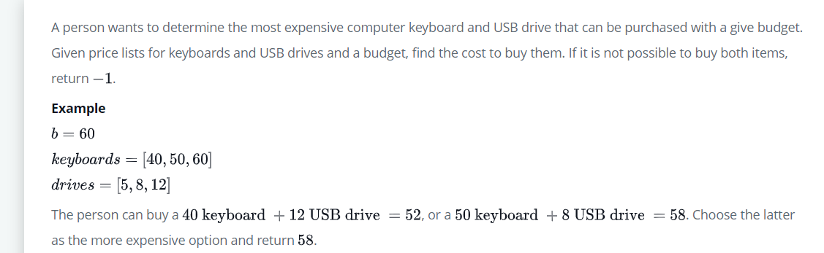

result=[]

    count=0

**for** i **in** keyboards:

**for** j **in** drives:

**if** i+j<=b:

                result.append(i+j)

    n=**len**(result)

**if** n==0:

        count=-1

**else**:

        count=**max**(result)

**return** count